Lab 9: Standalone PV system with Battery Storage

Note: The requested data is often emphasized in the lab instructions with italicized text.

9.1 Objective
To integrate MPPT with charging of battery through a buck converter in standalone PV energy system. To perform medium-term simulations of standalone PV system.

9.2 Simulation Software
The computers in EGR building are loaded with MATLAB/Simulink software. Make sure to download same version of MATLAB, Simulink and Simscape if you prefer to use your laptop for the lab sessions.

9.3 Simulink Model Development
Build a visually pleasing and clean model with less wiring complexity. Negative points apply for unpleasant models, though they are correct. After model completion, select all blocks (Ctrl + A), go to “Format” tab and change “Auto name” to “Name on” to display block names as shown in Figure.

Do not take screenshot of the model and results. Rather follow the approach below to copy the model and scope results to your lab report.

How to Copy Simulink Model to Report:
Open subsystem Maximize window Fit to View.
Format Screenshot Send Bitmap to Clipboard Paste in Word Document.

How to Copy Scope to Report:
Open scope Maximize window Scale X and Y axes Limits.
File Copy to Clipboard Paste in Word Document.

9.4 Designing Standalone PV Energy System
Read Sections 9.2 to 9.6 in textbook to understand the simulation of standalone PV energy system.

Download Lab9.zip from the Canvas and extract the folder. Set the current directory of MATLAB to the Lab9_Part1 folder. Otherwise, you will get errors in running the simulations.

Open the Buck_Charger.slx file. Do not run the simulation yet. The complete simulation model is shown in Fig. 9.1. The DC/DC buck, battery and MPPT charge subsystems are empty, and they should be developed similarly to Figs. 9.2 to 9.5. Please note that the parameters in Simulink blocks are case sensitive.

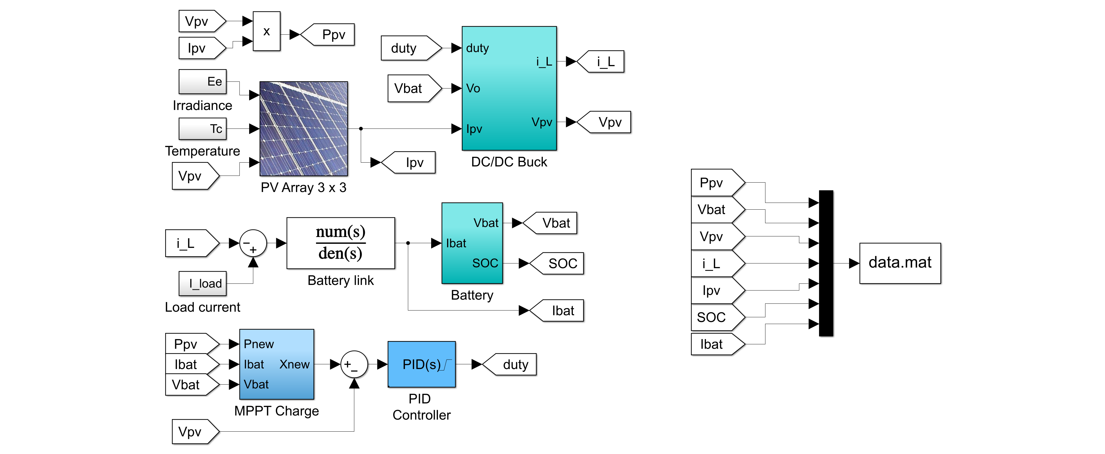
Fig. 9.1 Complete standalone PV system with DC/DC buck converter and battery energy storage.

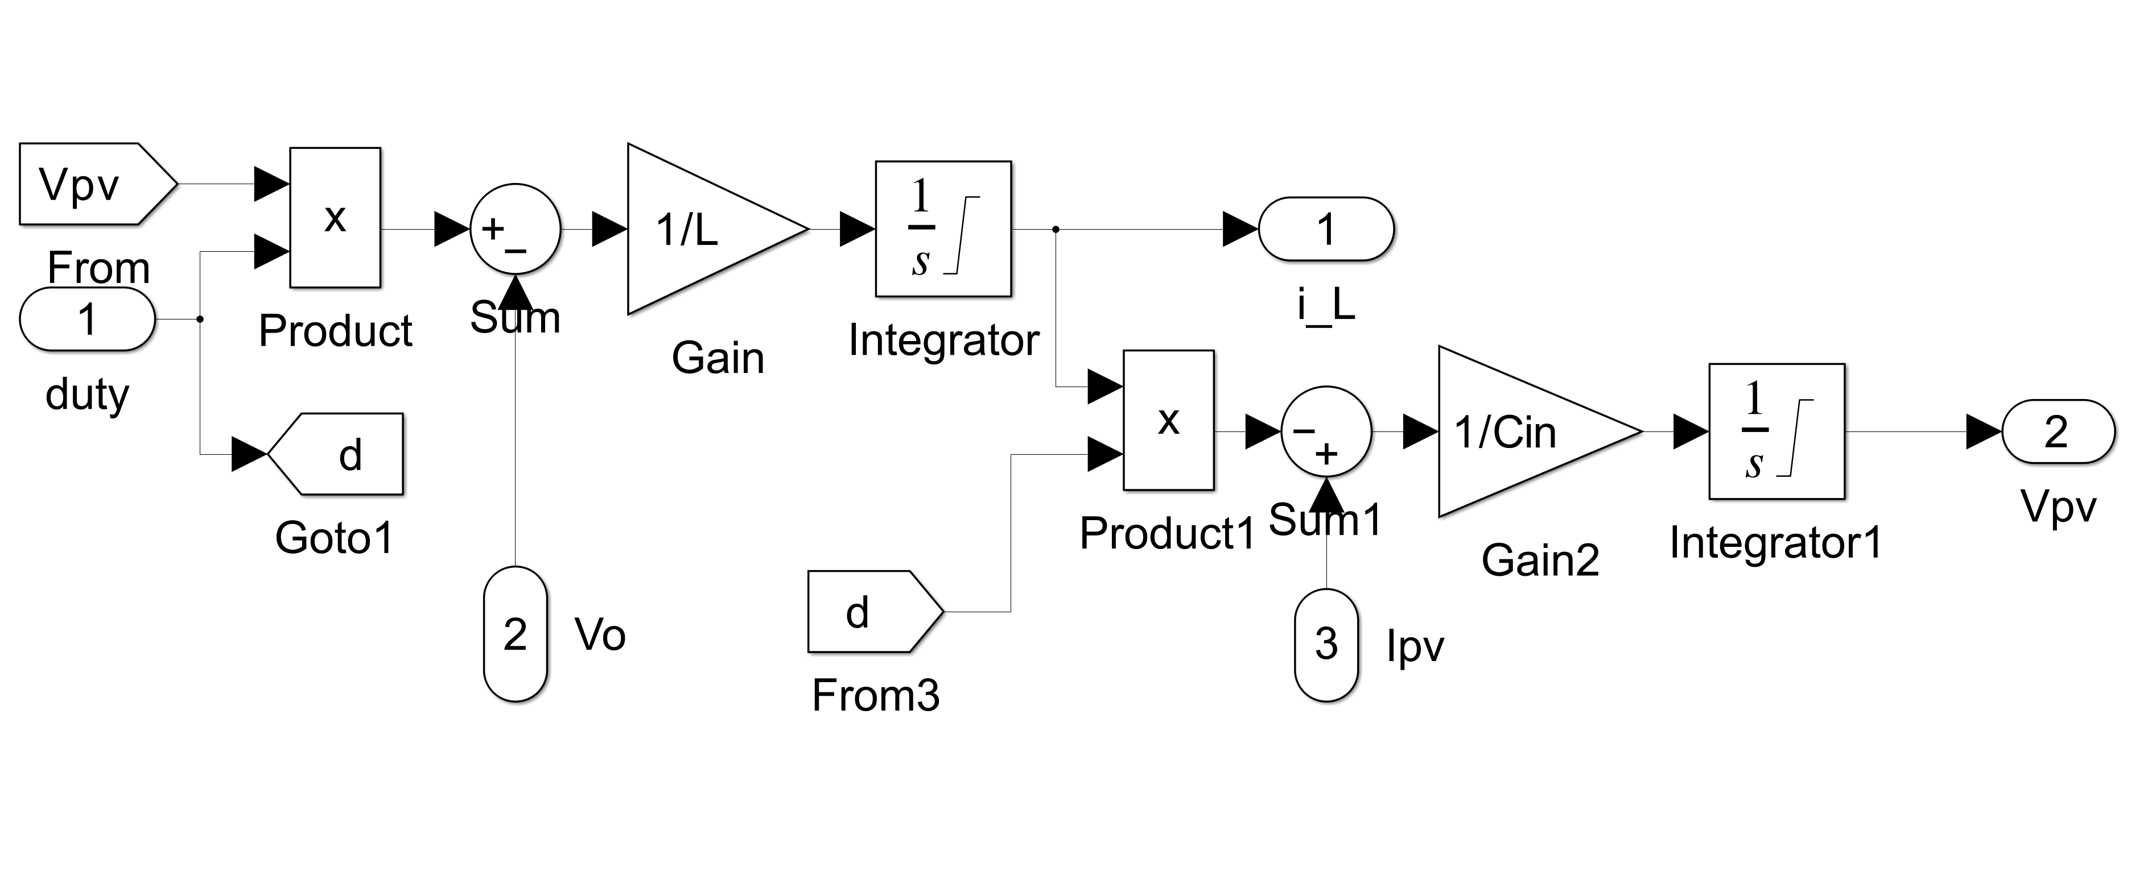
Fig. 9.2 Simulink model of DC/DC buck subsystem.
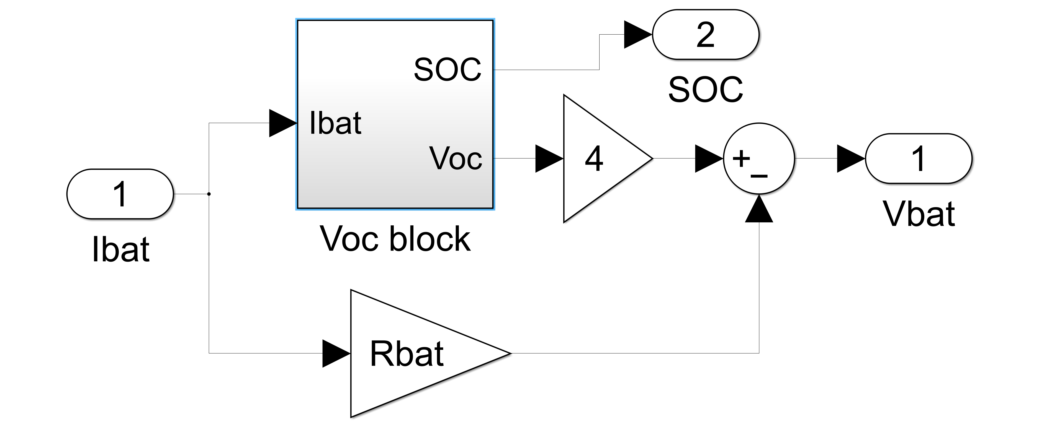
Fig. 9.3 Simulink model of battery subsystem.

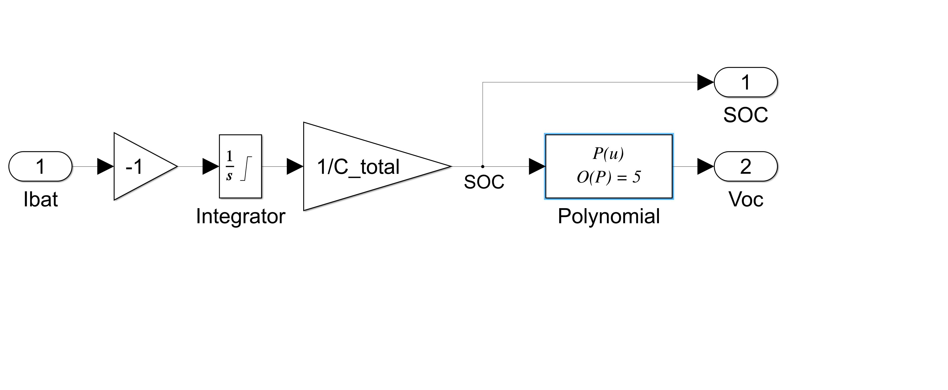
Fig. 9.4 Simulink model of Voc subsystem.

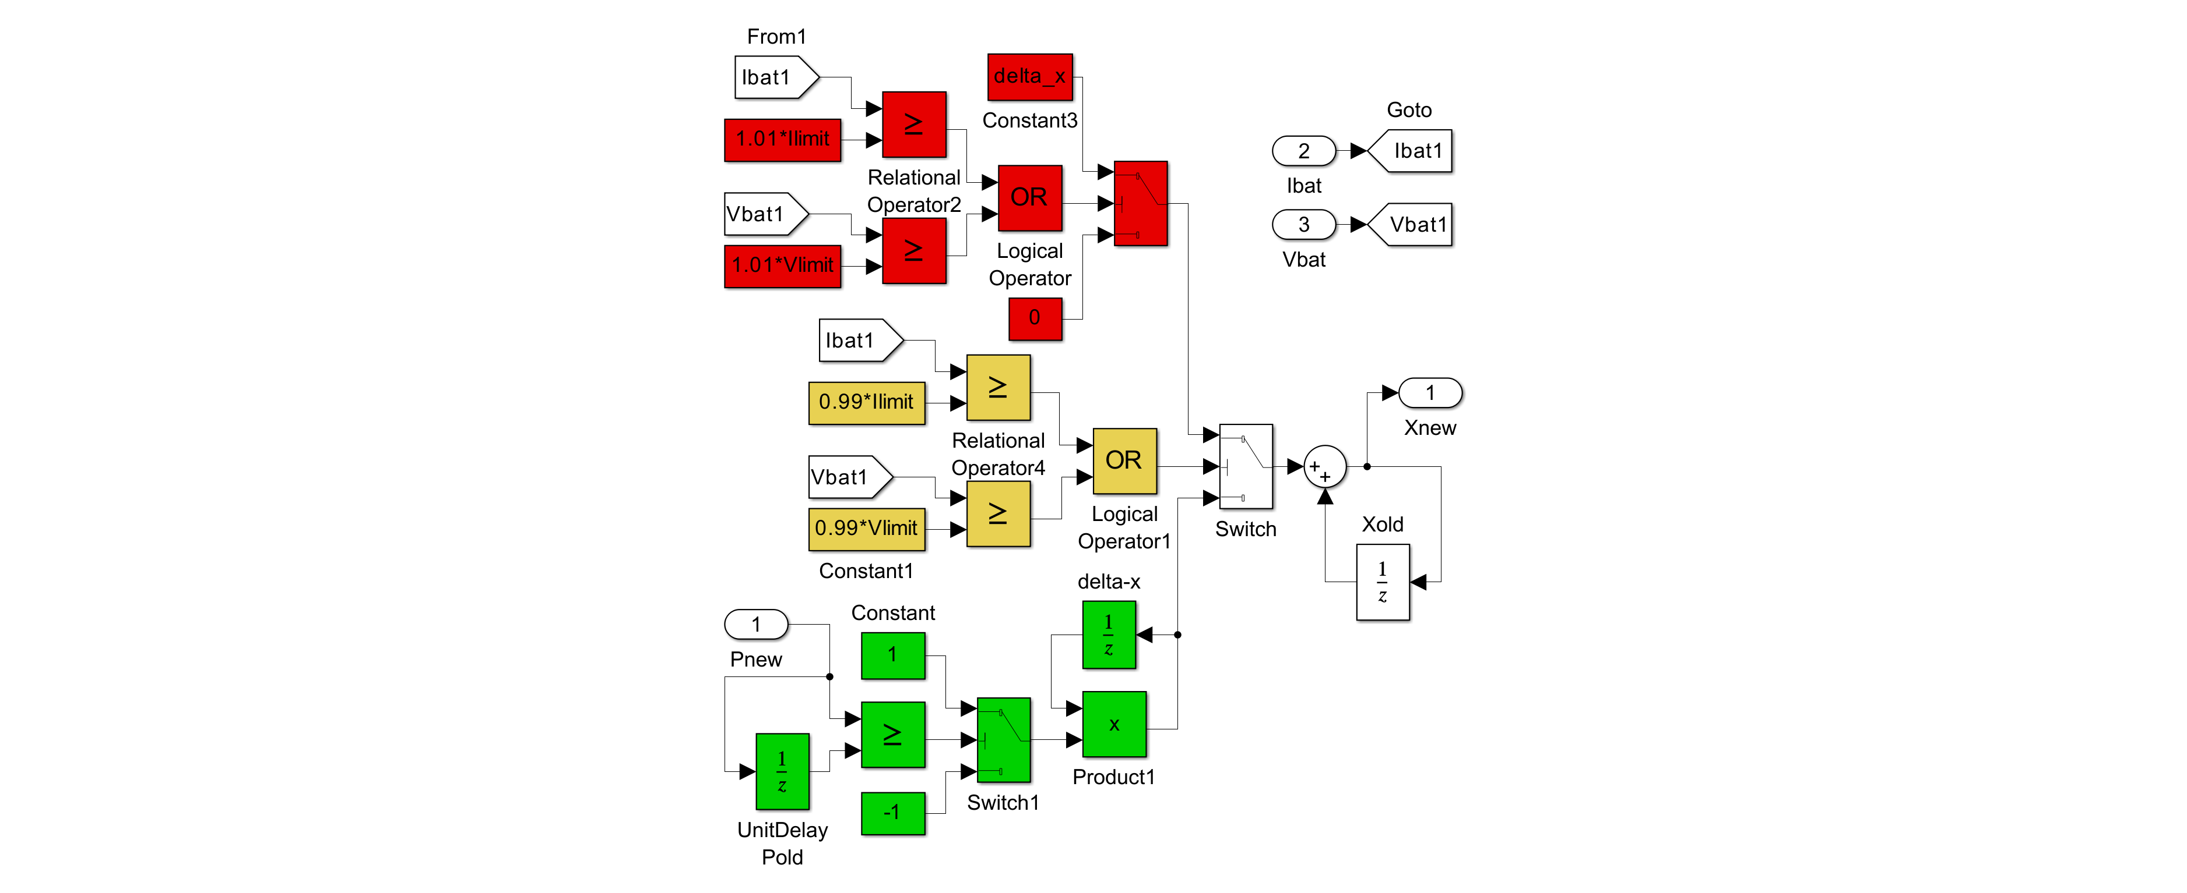
Fig. 9.5 Simulink model of MPPT charge subsystem.
Apply following parameters for the blocks in the DC/DC buck subsystem:
- Integrator block. Initial condition: 0, Upper saturation limit: inf, Lower saturation limit: 0
- Integrator1 block. Initial condition: Voc_array, Upper saturation limit: inf, Lower saturation limit: 0

Apply following parameters for the blocks in the battery subsystem:
- Integrator block. Initial condition: C_init, Upper saturation limit: C_total, Lower saturation limit: 0
- Polynomial block. Polynomial coefficients: P01A

Apply following parameters for the blocks in the MPPT charge subsystem:
- For all goto blocks, set tag visibility to global
- For all blocks, replace the sample time of -1 by 1/fmpp
- Initial condition for Pold (UnitDelay) block: 1e3
- Initial condition for Delta-x (UnitDelay) block: delta_x
- Initial condition for Xold (UnitDelay) block: x_init
- Threshold value for switch blocks: 0. Criteria for passing first input in switch block: u2 >= Threshold.

Once all the subsystems are developed, open the Batch_Run_Buck.m file and run the program to produce a figure similar to Fig. 9.40 in textbook. It takes a while to produce the plots, so please be patient. Maximize all the figures. The Batch_Run_Buck.m file initializes the parameters, runs the simulation model and produces the results. In the figure, go to Edit tab and press Copy Figure and paste in your lab report. Explain each plot thoroughly. Results without explanation will receive half the points only. Keep all the models you have developed in your report.

Run “Control_Buck.m” file and note all results printed in MATLAB command window. Explain each line printed in command window. Explain how Kp, Ki, Kd and Tau are calculated for PID controller? Include Bode diagram produced by this file.

9.5 Instructions for Lab Report
Detailed instructions for the lab report preparation are available on Canvas. Each team member should identify his/her portion of the writing in both the pre-lab (if exists) and post-lab reports.

The report should include the following results and analysis:
- 1 figure along with explanation for standalone system
- 1 Bode diagram produced by Control_Buck.m file
- Screenshot of simulation models you have developed

